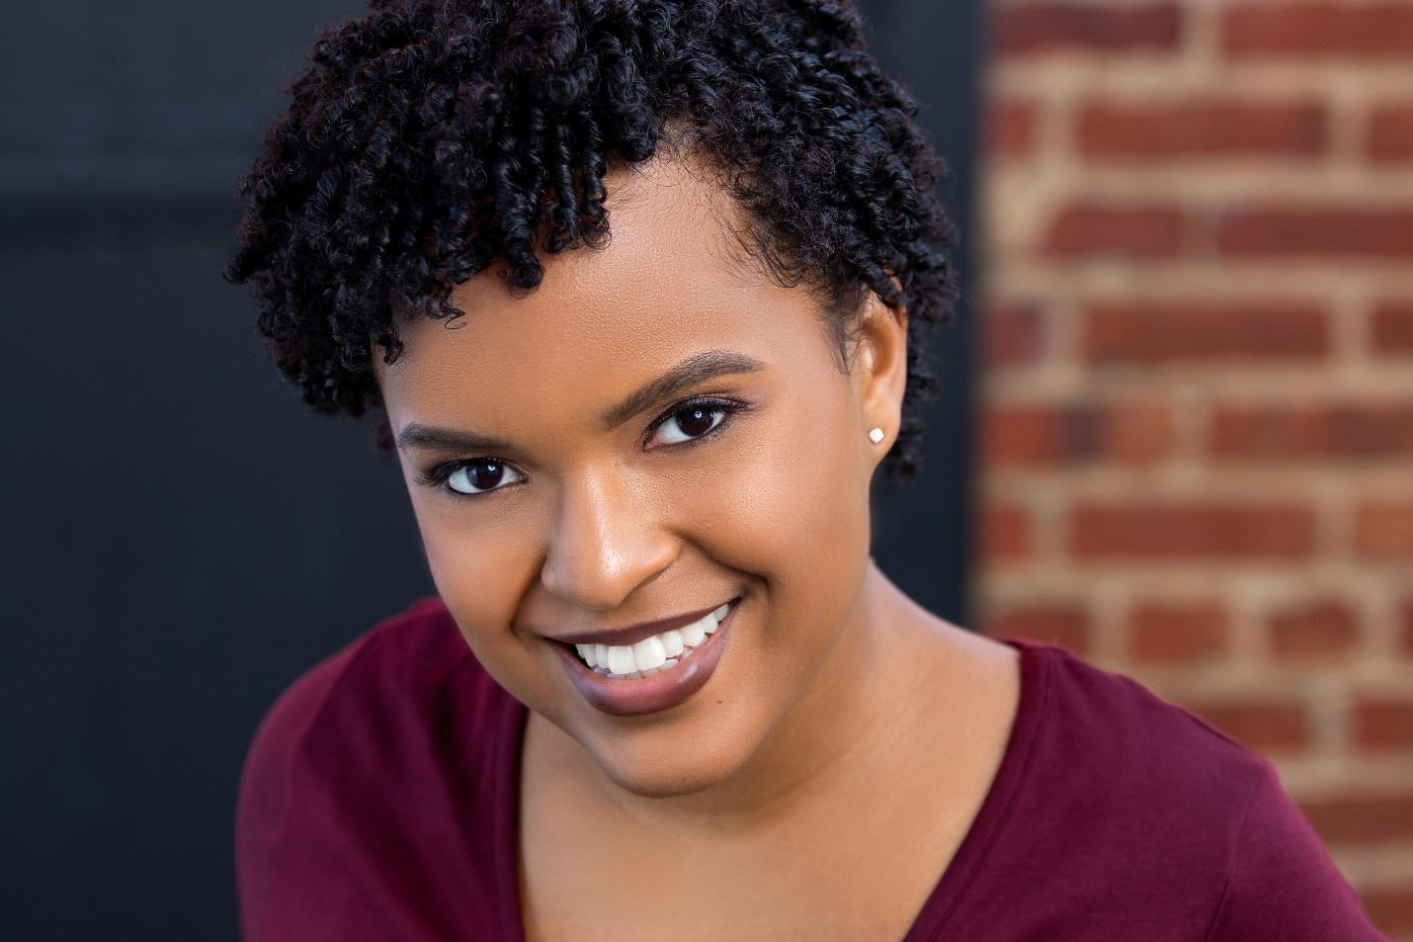
Courtney Simpson is a Licensed Graduate Professional Counselor, a wife, a daughter, sister, friend, and DMV native. Born in Washington, D.C. and raised in Prince George’s County, Maryland, Courtney received her undergraduate degree in psychology at the University of Maryland, College Park (UMD). From there she went on to obtain her master’s in clinical mental health counseling from The Chicago School of Professional Psychology.
Courtney’s counseling journey lead her from working at crisis centers in Maryland, while assisting high risk adult populations dealing with moderate/ severe mental health concerns, homelessness, abuse/ trauma, substance abuse and medication management to working with DCPCS schools as both counselor and engagement specialist to offer additional support to help prevent at-risk youth from retention and dropout. Currently, Courtney is a Program Manager and therapist for SMILE Therapy Services, LLC, overseeing the school-based mental health programs and partnerships in the District as well as providing therapeutic services to clients in the community.
Courtney believes that we are all here, brilliantly and wonderfully made, for a destined purpose and while she continues to discover her own, she is determined to live each day better than the last. Courtney finds her bliss in tapping into all things creative from writing stories, pursuing acting, devouring books, learning new ways to keep her garden alive, and binge-watching Korean dramas on Netflix. For her, life is about the path we are on while we are on it, doing our best to grow in mind, body and spirit and that through her own healing she might help others heal.

